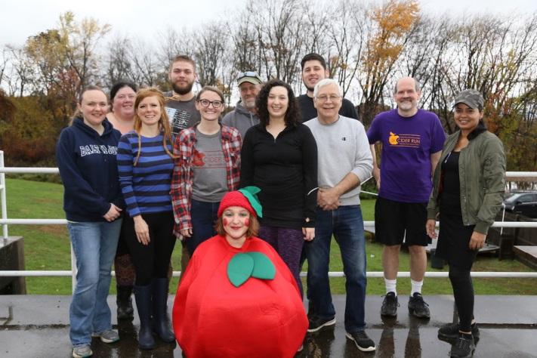
FOR IMMEDIATE RELEASE
Contact: Maggie Ducheney
Valley Educational Associates, Inc.
Phone: 413.349.4120
Fax: 413.349.4122
www.valleyeducational.org
ducheneyVEA@yahoo.com

Valley Educational Associates’ 5k Cider Huge Success
HATFIELD, MA (November 21, 2018) Valley Educational Associates, Inc. hit record numbers with 210 registered runners, eight sponsors, and 12 in-kind donors this year with its fourth annual 5k Cider Run from November 3, 2018. The gross revenue was $18,483 which surpassed the goal of raising $15,000 to offset programmatic costs.
Kate DaSilva, Executive Director, shares her deep gratitude, “The 5k Cider Run is our largest annual fundraiser and it could not have been accomplished without direction and oversight by Maggie Ducheney. Under her execution and collaboration, our staff of Tim, Damaris, Jen, Kourtney (our intern from Springfield College), Gina, Anthony, Sarah, Jess, Amanda, Brian, and Casey worked tirelessly to make the 5k Cider Run the best we’ve seen. I am additionally appreciative of our generous board of directors who contributed key items to the race.”
Valley Educational Associates thanks all those who sponsored and donated to this year’s run, including: PeoplesBank, Olympic Manufacturing Group, and Greenfield Savings Bank for being Silver & Custom Sponsors.
The 5K Cider Run fundraiser supplies learning and tools for adults with intellectual and developmental disabilities to have fulfilling day and supported-employment programs.
About Valley Educational Associates, Inc.: Incorporated as a nonprofit in 1982 to provide vocational training and employment services to adults with disabilities. Valley Educational Associates serves over 80 individuals in three program locations in Western Massachusetts. The program model is structured into Community Based Day Services (CBDS) and Supported Employment (SE) settings. Valley Educational Associates has proudly achieved nine consecutive Certifications with Distinction and participated in ten distinctive survey and certification reviews with the Office of Quality Enhancement (OQE) within the Office of Quality Management. Valley Education Associates is a member of the Human Service Forum, Providers’ Council, Greater Holyoke Chamber of Commerce, and Northampton Chamber of Commerce.

Our Mission: Valley Educational Associates’ specialized professionals strive to improve the quality of life for people with developmental disabilities.
###

