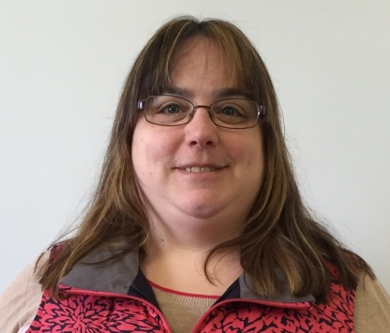
FOR IMMEDIATE RELEASE
Contact: Maggie Ducheney
Valley Educational Associates, Inc.
Phone: 413.349.4120
Fax: 413.349.4122
www.valleyeducational.org
https://www.facebook.com/ValleyEducational/
ducheneyVEA@yahoo.com

Valley Educational Associates Announces Staff Promotion
HATFIELD, MA (November 9, 2017) Valley Educational Associates, Inc. is pleased to announce Jennifer Goselin, LMHC has been promoted to Clinical Services Supervisor for the agency. Goselin has demonstrated commitment and excellence in her position from the past two and a half years serving the three locations in Western Massachusetts.
Formerly, Goselin served as one of Valley Educational Associates’ members of the psychological services team. In her new role, Goselin will oversee the agency’s clinicians and day service participants. She will implement evaluation and assessment improvements for the program participants. This position ensures that developmental and mental health state and federal policies are upheld. “I'm looking forward to maintaining our strong clinical focus at VEA, and finding creative strategies to help our individuals succeed,” states Jennifer Goselin.
Goselin holds a Master’s Degree in Mental Health Counseling from Walden University. She serves on the board of directors for Arena Civic Theatre in Greenfield and is a member of the Northfield Cultural Council and 100 Who Care Franklin County.
Kate DaSilva, Executive Director, discusses the value of having Goselin manage the clinical functions at Valley Educational Associates. “When our Clinical Services Supervisor position became available, I was excited to promote Jennifer to this new role. She has a true talent for connecting with our program participants and ensuring our agency is following protocol. ”

About Valley Educational Associates, Inc.: Incorporated as a nonprofit in 1982 to provide vocational training and employment services to adults with disabilities in Western MA. Valley Educational Associates serves over 95 individuals in three program locations in Western Massachusetts. The program model is structured into Community Based Day Services (CBDS) and Supported Employment (SE) settings. Valley Educational Associates has proudly has achieved nine consecutive Certifications with Distinction and participated in ten distinctive survey and certification reviews with the Office of Quality Enhancement (OQE) within the Office of Quality Management. Valley Educational Associates is a member of the Human Service Forum, Providers’ Council and Northampton Chamber of Commerce.

Our Mission: VEA’s specialized professionals strive to improve the quality of life for people with developmental disabilities.
###

